SQL QUESTIONS AND ANSWERS

Q1) FIND THE PRODUCT ID ,PRODUCT NAME,AND PRODUCT PRICE FROM THE TABLE WHERE PRODUCT PRICE IS GREATER THAN 100.

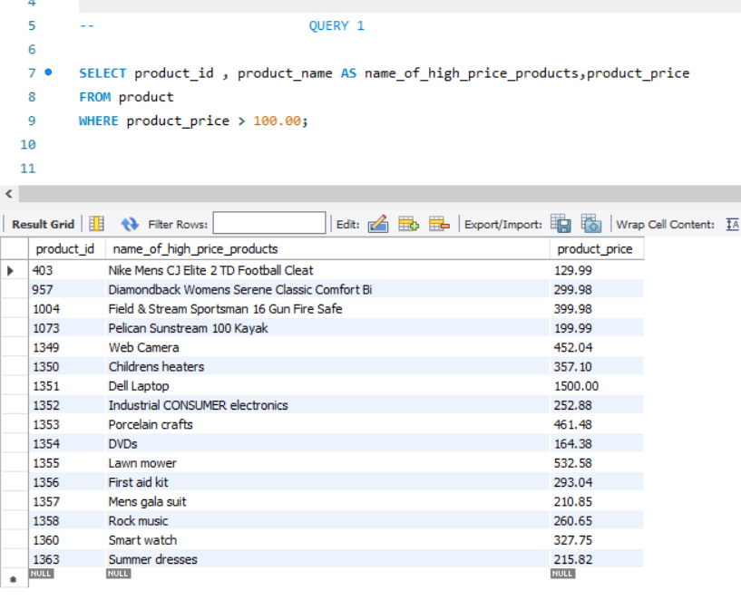

Q2) FIND THE CUSTOMER FIRST NAME , CUSTOMER LAST NAME , SEGMENT,CUSTOMER CITY,ORDER ID ORDER DATE AND CUSTOMER STATE WHERE CUSTOMER STATE IS EQUAL TO FLORIDA.

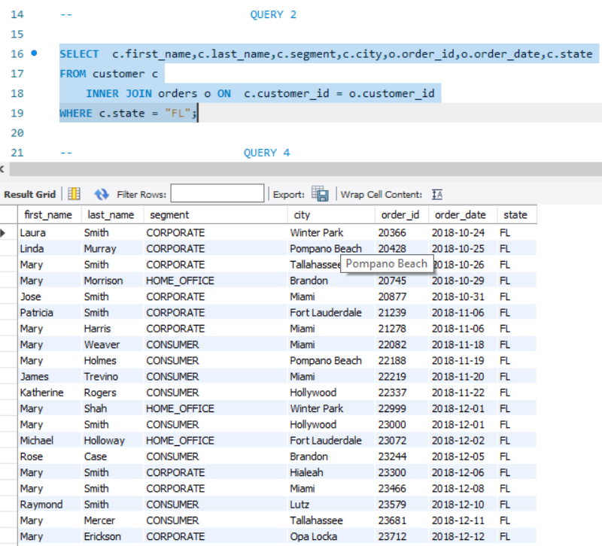

Q3) FIND PRODUCT NAME, PRODUCT PRICE, DEPARTMENT NAME AND CATEGORY NAME WHERE CATEGORY NAME IS ‘COMPUTER ’ OR ’TOYS’ OR ’TENNIS’ OR ’RACQUET’

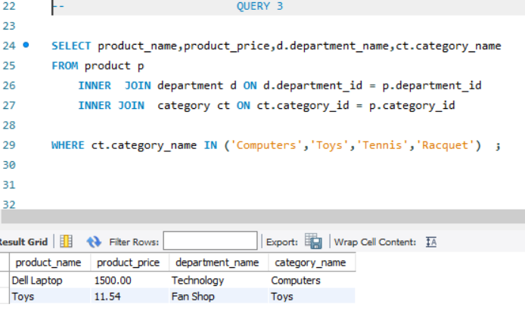

Q4) FIND THE NUMBER OF SHIPPING FOR WHICH SHIPPING IS DELAYED IN EACH CITY AND ARANGE THE CITY AS THE CITY WHICH HAS MOST NUMBER OF SHIPPING DELAYED AT THE TOP AND THE CITY WITH THE LEAST DELAYED SHIIPPING ORDER IS AT BOTTOM.

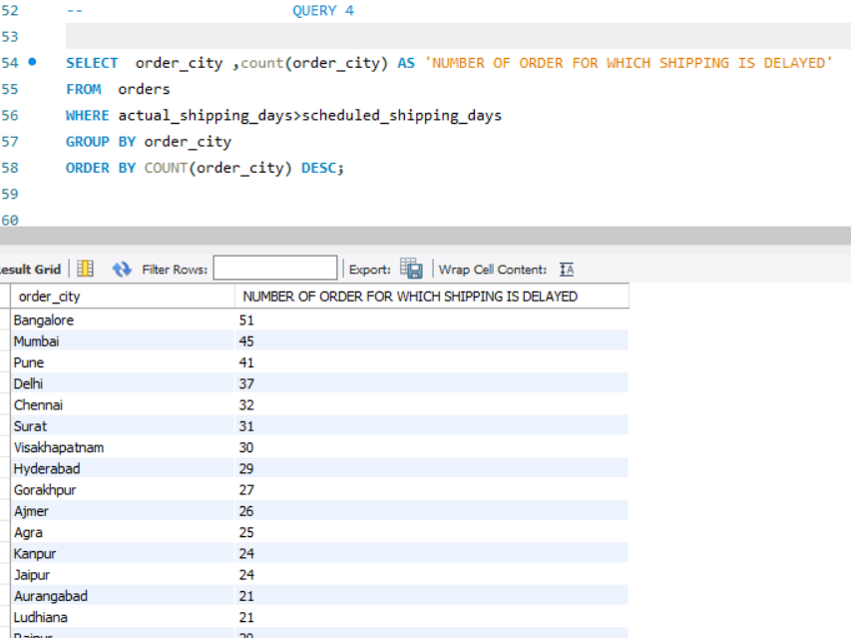

Q5) FIND THE BUYER SEGMENT AND ARRANGE THEM IN THE DESCENDING ORDER.

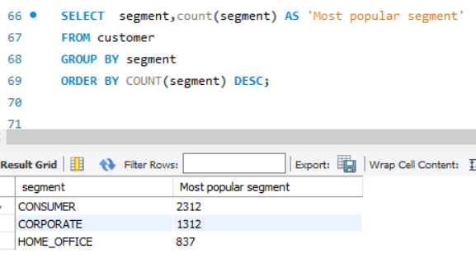

Q6) FIND THE TOTAL NUMBER OF ORDERS PALCED IN THE FIRST QUARTER OF 2021.(NOTE :- FIRST QUARTER JANUARY TO MARCH)

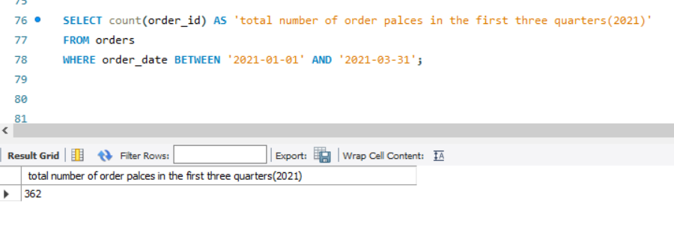

Q7) FIND THE STATES WHICH HAS MORE THAN 1 BUYER SEGMENT PRESENT.REPRESENT AS NUMBER OF STATES AND NUMBER OF SEGMENT PRESENT IN THAT STATE.

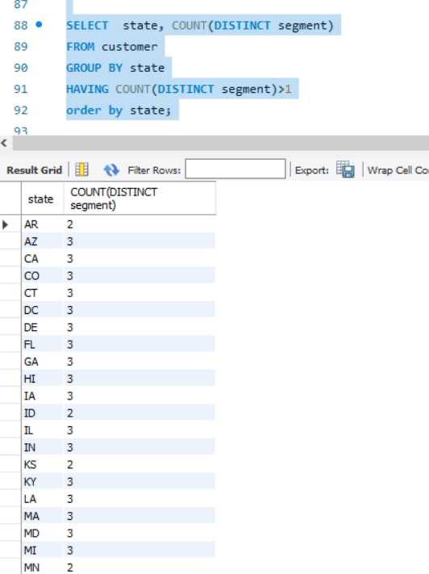

Q8) SELECT CUSTOMER LAST NAME ,FIRST NAME, CITY, STATE, STREET,ZIPCODE, CUSTOMER_ID

WHERE CUSTOMER SEGMENT IS ‘CORPORATE ’ AND ARRANGE THE RESULT DATA BY LASTNAME.

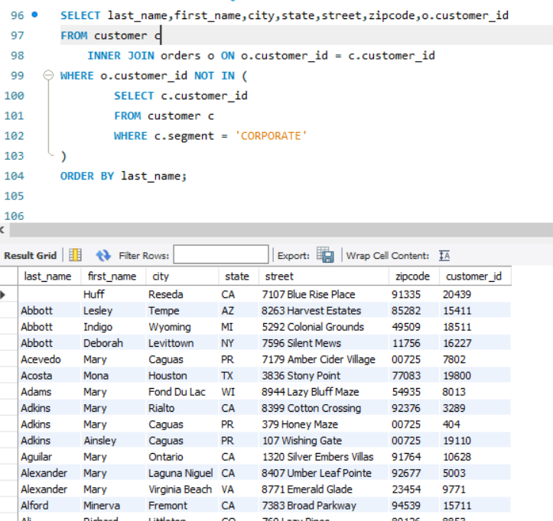

Q9) FIND THE UNIQUE CUSTOMER ID ,FIRST NAME,LAST NAME, CITY,STATE,STREET,ZIPCODE,ORDER DATE FOR PRODUCT ‘Nike Mens Free 5.0+Running shoe’ and arrange the result data a/c to customer id.

